4. Market Analysis in Banking Domain

Step1:

val mydf = spark.read.format("csv").option("header","true").option("delimiter",";").load("banking.csv")

result:



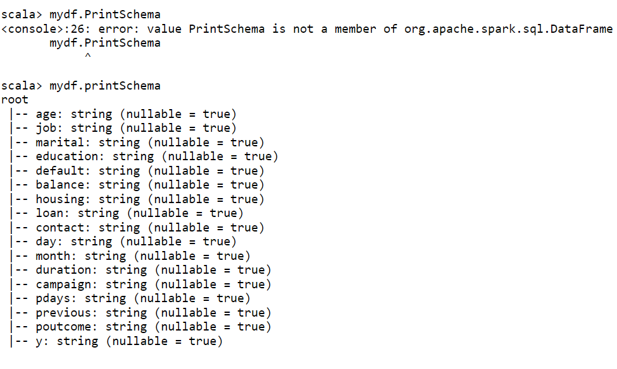

step2:

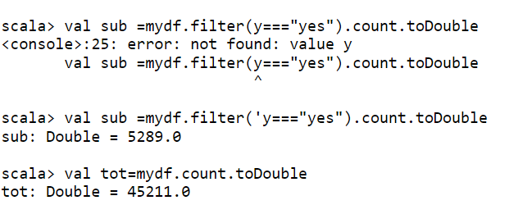

val market_success=(sub/tot)*100

output:

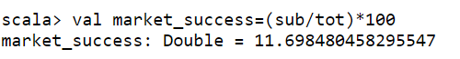

val fail =mydf.filter('y==="no").count.toDouble

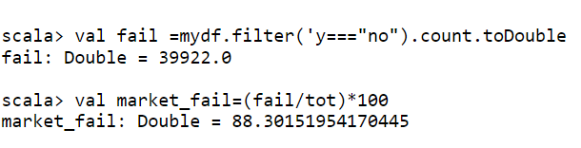

3. minimum age:

val miniAge = mydf.agg(min('age));

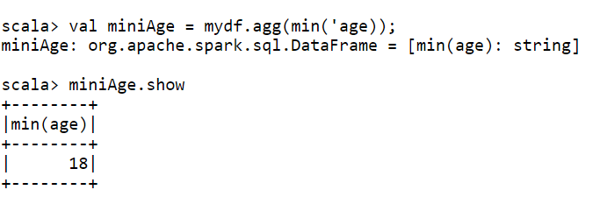

Maximum age:

val maxAge = mydf.agg(max('age));

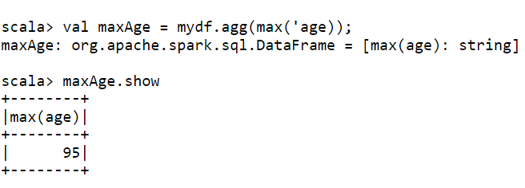

Mean age:

val meanage = mydf.agg(mean('age));

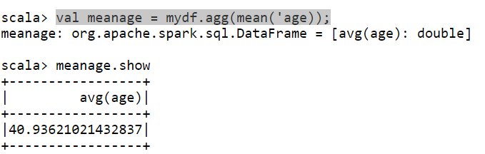

4.mean balance:

val meanbal = mydf.agg(mean('balance));

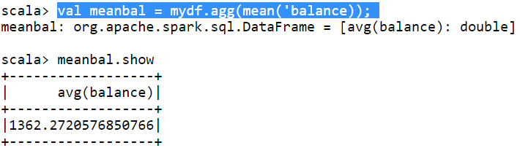

Median balance:

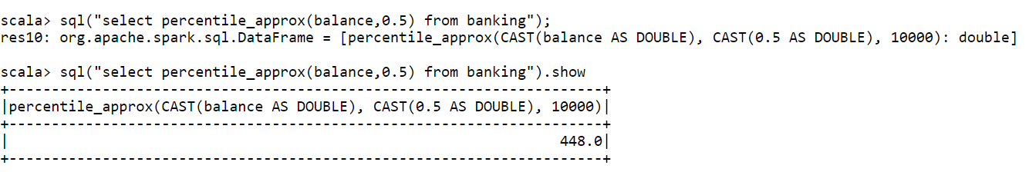

4.checking if age matters:

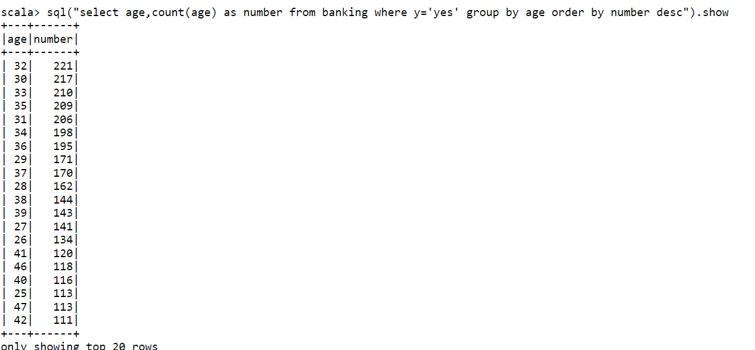

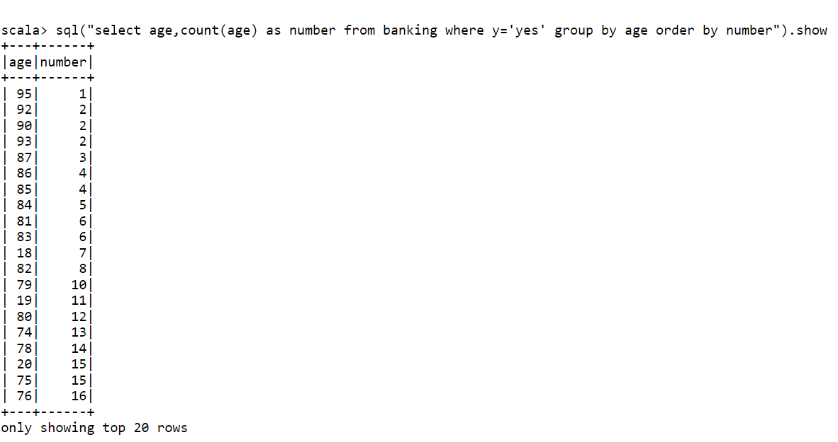

Yes age matters.

5.checking if marriage matters:

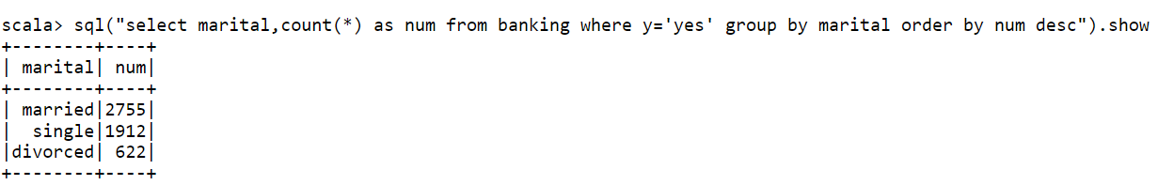

Yes it affects.

6.checking age, marriage both matters:

sql("select age,marital,count(*) as num from banking where y='yes' group by marital,age order by num desc ").show 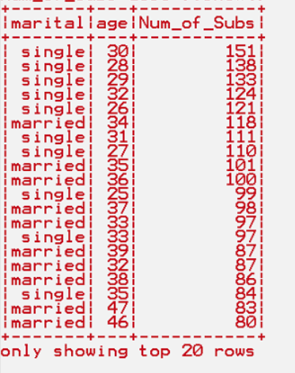

this tells us that both are important to get more subscriptions

7. doing feature enginerring :

val new_df=mydf.withColumn("age_cat",when('age<25,"young").otherwise(when('age>60,"old").otherwise("middle_age")))

grouping by age_cat:

new_df.groupBy("age_cat","y").count.show

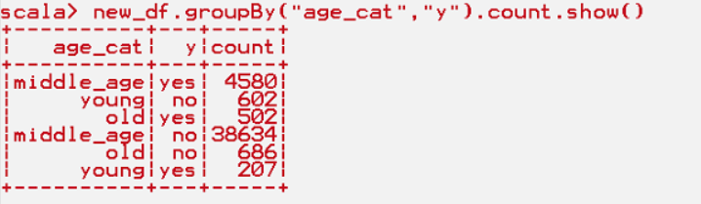

The out put is showing that the middle aged persons are subscribed more than any other (below 25,above 60).